**8TH WEEK’S REPORT**

Maze Solving Robot’s Sensor Arrangement

Since the initial plan for having three sensors at the front part of the robot conclusively seem to have a lot of problems, we discussed about this again and concluded that we are going with seven sensors.

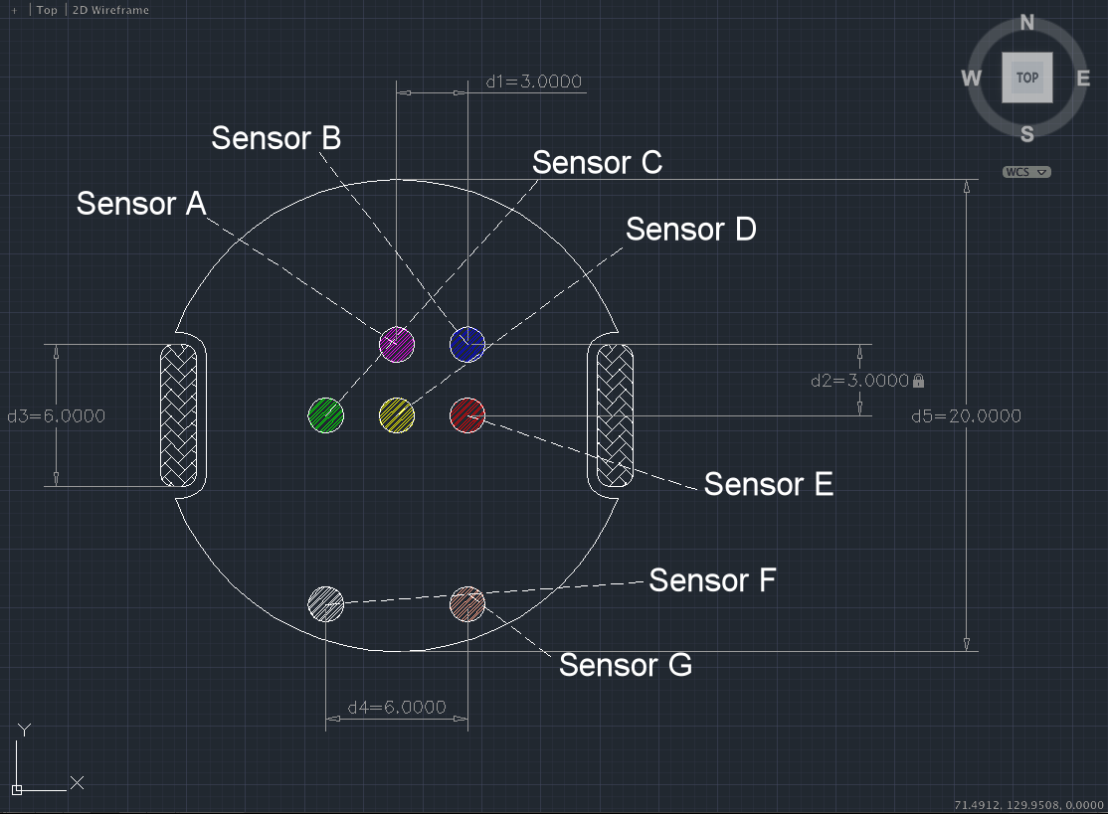

Figure 1 : The sketch diagram of the new sensor arrangement of the maze-solving robot

We decided to move the three sensors **(Sensor C, D, and E)** that we proposed last week to the center of the robot. This way the robot’s center would stop at the center of the pivot during turns without having to predict the time interval needed to be there, unlike our previous idea. For it to be able to distinguish + and T intersections, we put the new sensor A in front of Sensor D. To distinguish a + intersection and a finish tile, we also put the new sensor B next to Sensor A.

We also considered the smoothness of the robot’s path. This is one of the problems that were mentioned last week. To troubleshoot this problem, we decided to put the new **Sensors F and G** which works together with **Sensors C and E** to make sure the robot is going through the right path. If because of the wheel’s installment or the motor’s difference in angular velocity the robot becomes misdirected, the sensors would detect this misdirection and command the motors to align the robot straight.

For example if the left motor’s angular velocity is slightly higher than the right, the **left sensor ( C )** which initially senses white would sense black. That time it would command the right motor to rotate faster than the left to rectify the robot’s path.

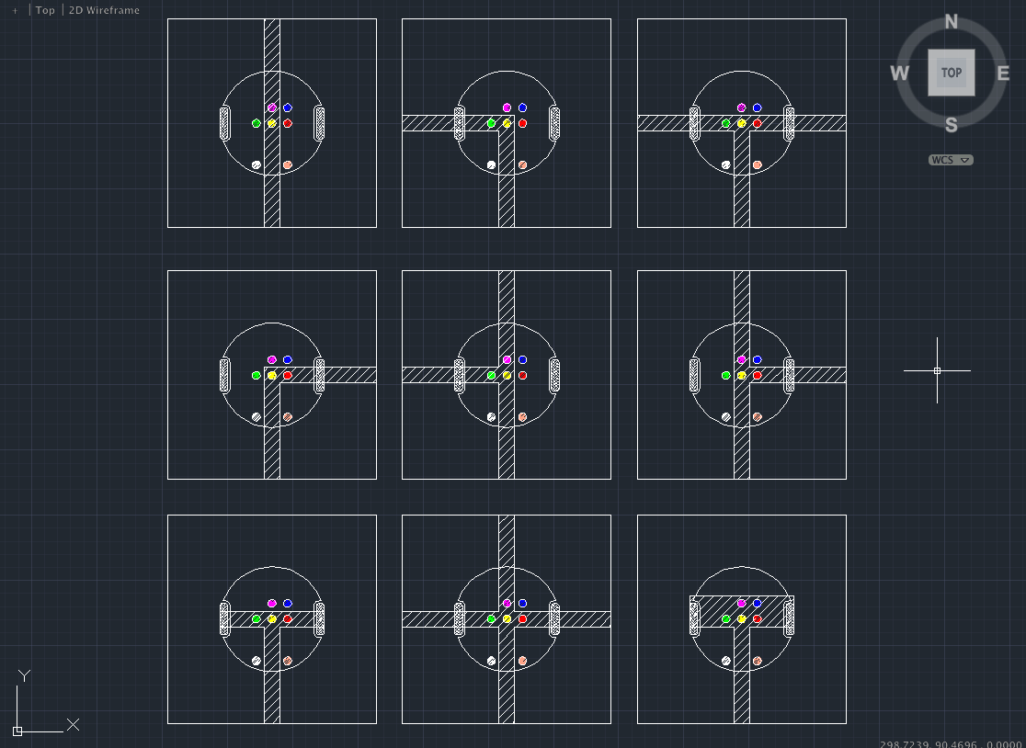

Figure 2 : The sketch diagram of the maze solving robot on different situations on various tiles

One thing we need to be careful about is the distinction between a start tile and a T intersection tile. In this case the **sensors F and G** would come into play. The diagram shows it wrong, but we will make the **sensors F and G** so that it would be far enough from the center of the robot to avoid sensing the black side lines of the start tile. In case the robot detects a T intersection or a start tile, the robot would have to rotate itself at least by 90°. During so, we make the robot sense the presence of a line when it is rotating by 90°. When it detects a line, we make the robot consider that as a T intersection and make it stop rotating after 90°. If it does not, we make the robot consider otherwise and make it rotate 180° and go back.

Research done by Richard

Sensors

Reflectance Sensor

Research done by Soumya

Actuators

**Tamiya Power Dash Motor**

Scale: 1/32

Cost: 420 yen

Though we don't have the specifications for this part, I believe it was the same motor we used in the visual thinking class so I'm certain it has enough torque. However since I don't know the RPM and am having trouble finding it I can't exactly tell what the correct gear ratio we would need to cause our robot to move the correct speed. The robot needs to move slow enough so that the sensors have time to adjust to whatever it is they are reading, currently 5cm/s is the speed we are wanting, however if after we build it we find that it can go faster the motor would be able to handle that.

http://www.1999.co.jp/10131566

**Off-road Tire Set**

58mm Dia

Item No. 70145

Cost: 504 yen

The description of these wheels says low rolling resistance, will help with reducing the slipping of the robot whenever the wheels move.

http://www.tamiya.com/japan/products/70145narrow_tire/index.htm

Motors: Sorry I don't know what other motors are out there other than the different power options for that same time and since I don't know the different RPM's I don't know how over or under powered they might be.

**Wheels (not used):** http://www.tamiya.com/japan/products/70111sports_tire/index.htm

Diameter: 56mm

Width: 25 mm

The robot is not very heavy and the difference between the traction for this and the traction for the thinner wheel's we did choose would not be much. The big reason for not taking this is the width, using just two of these would take up 1/4 the total width of the area wherever we place the wheels.

**Wheels (not used):** http://www.tamiya.com/japan/products/70096off_road_tires/index.htm

Diameter: 50mm

Width: 30mm

For the same reason as the other wheels that we eliminated we are taking out these from consideration, they are just too wide and will take up too much area. In addition the larger tread on the tires is completely unnecessary for our robot, we are driving on a smooth surface indoors.

Research done by Morgan

Budget Estimation for the whole Robot

|  |  |
| --- | --- |
| Type | Price |
| Off-road Tire Set | 504 |
| Tamiya Power Dash Motor | 420 |
| Chassis Budget | 2000 |
|  |  |
|  |  |
|  |  |
| Total |  |